22AIE211 Introduction to Communications and IoT

Lab sheet-2

Signal Modulation and Demodulation Techniques

**Name: Girish S**

**Roll No: AM.EN.4AIE22044**

**Submission Date: 3/5/24**



**clc;**

**close all;**

**clear all;**

**m = [0.5 1 1.5];**

**Am = 5; %Amp. of modulating signal**

**fm = 20; %frequency of modulating signal**

**Tm = 1/fm;**

**t = 0:0.001:1;**

**ym = Am*sin(2*pi*fm*t);**

**subplot(5,1,1);**

**plot(t,ym)**

**title('Message Signal');**

**%Carrier signal**

**Ac = Am;**

**fc = 100;**

**Tc = 1/fc;**

**yc = Ac*sin(2*pi*fc*t);**

**subplot(5,1,2);**

**plot(t,yc)**

**grid on;**

**title('Carrier Signal');**

**%AM Modulation**

**index = 0;**

**titles = {'index=0.5', 'index=1', 'index=1.5'};**

**for i = m**

**subplot(5,1,3+index);**

**index = index + 1;**

**y = Ac * (1+i*sin(2*pi*fm*t)).*sin(2*pi*fc*t);**

**plot(t,y)**

**title(titles{index});**

**end**

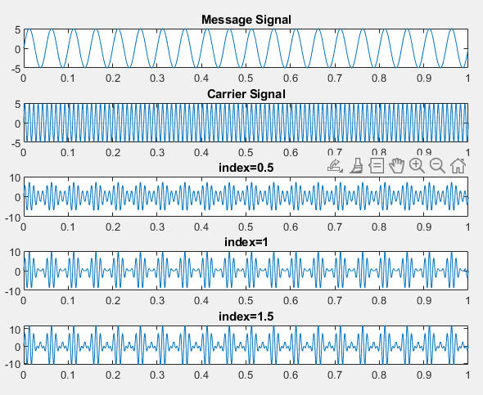



**clc;**

**close all;**

**clear all;**

**t = 0:0.001:1;**

**ym = 2*cos(pi*t); % message signal**

**yc = 4*sin(100*pi*t + deg2rad(10)); % carrier signal**

**yam = 4*(1+cos(pi*t)).*sin(100*pi*t + deg2rad(10)); % Amplitude modulated Signal**

**subplot(3, 1, 1);**

**plot(t, ym);**

**title("Message Signal");**

**subplot(3, 1, 2);**

**plot(t, yc);**

**title("Carrier Signal");**

**subplot(3, 1, 3);**

**plot(t, yam);**

**title("Amplitude Modulated Signal");**

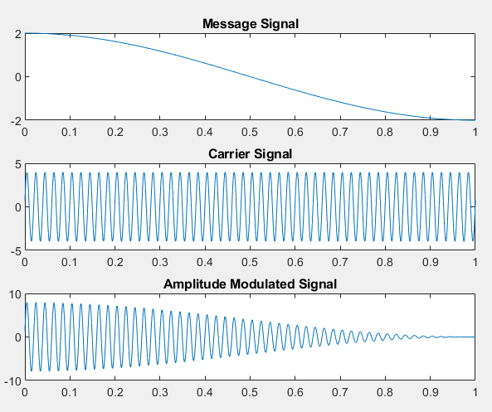



**clc;**

**close all;**

**clear all;**

**mf = 10;**

**fs = 10000;**

**fm = 35;**

**fc = 500;**

**Am = 1;**

**Ac = 1;**

**t = 0:1/fs:0.1;**

**ym = Am*cos(2*pi*fm*t);**

**yc = Ac*cos(2*pi*fc*t);**

**yfm = Ac*cos(2*pi*fc*t + mf*sin(2*pi*fm*t));**

**subplot(3, 1, 1);**

**plot(t, ym);**

**title("Modulated Signal");**

**subplot(3, 1, 2);**

**plot(t, yc);**

**title("Carrier Signal");**

**subplot(3, 1, 3);**

**plot(t, yfm);**

**title("Frequency Modulated Signal");**

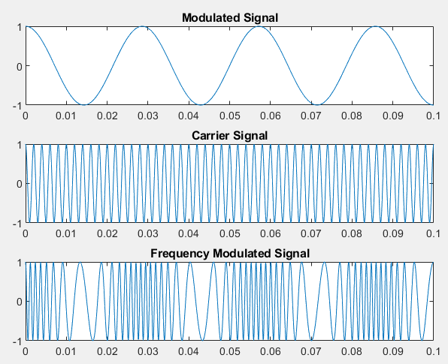



**clc;**

**close all;**

**clear all;**

**t = 0:0.001:5;**

**ym = sin(2*pi*5*t);**

**yc = square(5*t);**

**yam = sin(2*pi*5*t + ym);**

**subplot(3, 1, 1);**

**plot(t, ym);**

**title("Message Signal");**

**subplot(3, 1, 2);**

**plot(t, yc);**

**title("Carrier Signal");**

**subplot(3, 1, 3);**

**plot(t, yam);**

**title("Amplitude Modulated Signal");**

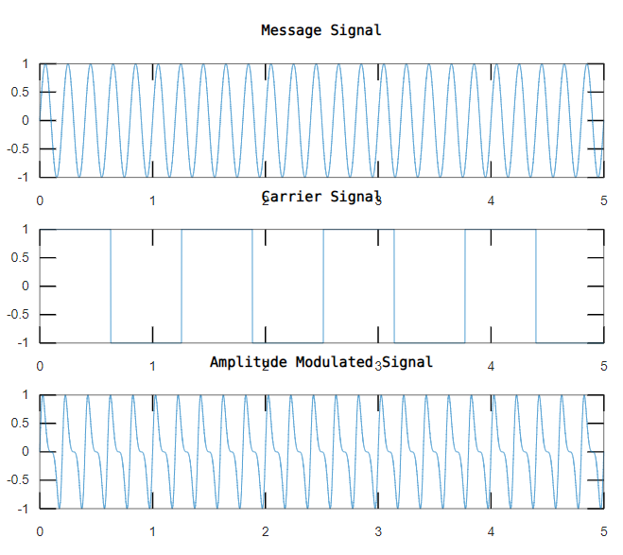



**clc;**

**close all;**

**clear all;**

**t = 0:0.001:1;**

**ym = 5 * sin(2*pi*10*t);**

**yc = 5 * sin(2*pi*50*t);**

**ypm = 5 * sin(2*pi*50*t + 4*ym);**

**subplot(3,1,1);**

**plot(t, ym);**

**title('Message Signal');**

**xlabel('Time (s)');**

**ylabel('Amplitude');**

**subplot(3,1,2);**

**plot(t, yc);**

**title('Carrier Signal');**

**xlabel('Time (s)');**

**ylabel('Amplitude');**

**subplot(3,1,3);**

**plot(t, ypm);**

**title('PM Modulated Signal (mp = 4)');**

**xlabel('Time (s)');**

**ylabel('Amplitude');**

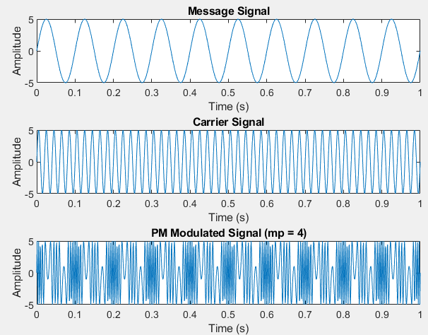

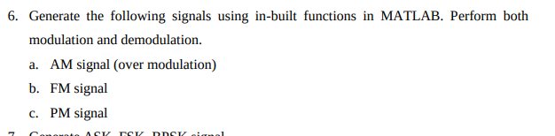

**clc;**

**close all;**

**clear all;**

**cf = 1;**

**Fs = 100;**

**mi_am = 5;**

**mi_fm = 5;**

**mi_pm = 2;**

**t = 0:1/Fs:5;**

**ym = sin(2*pi*1*t);**

**yc = sin(2*pi*cf*t);**

**yam = ammod(ym, cf, cf*mi_am);**

**tam = amdemod(yam, cf, cf*mi_am);**

**yfm = fmmod(ym, cf, cf*mi_fm, Fs);**

**tfm = fmdemod(yfm, cf, Fs, cf*mi_fm);**

**ypm = pmmod(ym, cf, cf*mi_pm, Fs);**

**tpm = pmdemod(ypm, cf, Fs, cf*mi_pm);**

**subplot(2,4,1);**

**plot(t, ym);**

**title('Message Signal');**

**xlabel('Time (s)');**

**ylabel('Amplitude');**

**subplot(2,4,5);**

**plot(t, yc);**

**title('Carrier Signal');**

**xlabel('Time (s)');**

**ylabel('Amplitude');**

**subplot(2,4,2);**

**plot(t, yam);**

**title('AM Modulated Signal');**

**xlabel('Time (s)');**

**ylabel('Amplitude');**

**subplot(2,4,3);**

**plot(t, yfm);**

**title('FM Modulated Signal');**

**xlabel('Time (s)');**

**ylabel('Amplitude');**

**subplot(2,4,4);**

**plot(t, ypm);**

**title('PM Modulated Signal');**

**xlabel('Time (s)');**

**ylabel('Amplitude');**

**subplot(2,4,6);**

**plot(t, tam);**

**title('AM Demodulated Signal');**

**xlabel('Time (s)');**

**ylabel('Amplitude');**

**subplot(2,4,7);**

**plot(t, tfm);**

**title('FM Demodulated Signal');**

**xlabel('Time (s)');**

**ylabel('Amplitude');**

**subplot(2,4,8);**

**plot(t, tpm);**

**title('PM Demodulated Signal');**

**xlabel('Time (s)');**

**ylabel('Amplitude');**

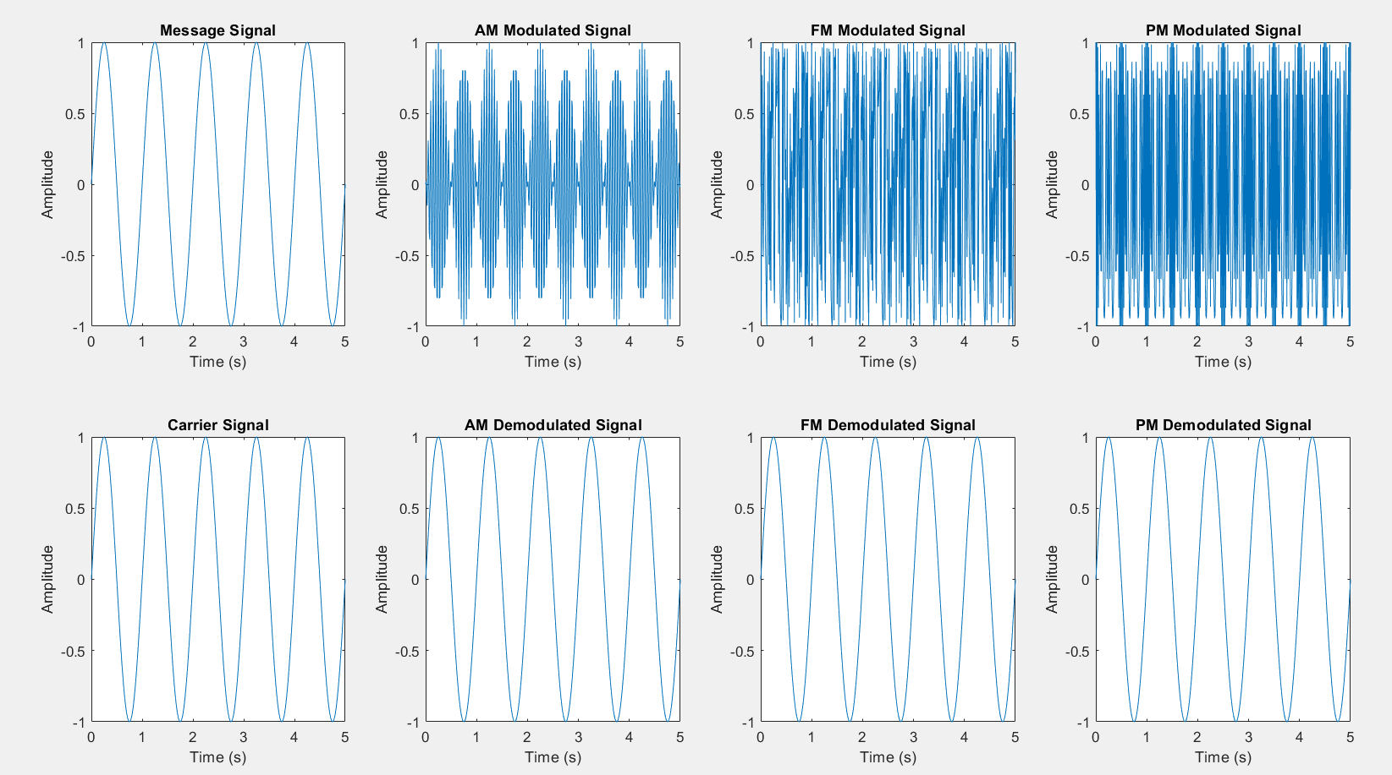



**clc;**

**close all;**

**clear all;**

**x = [1 0 0 1 1 0 1];**

**bp = 0.000001;**

**A1 = 10;**

**A2 = 0;**

**f1 = 10 / bp;**

**f0 = 5 / bp;**

**phi1 = 0;**

**phi0 = pi;**

**t_bit = bp / 100;**

**bit = [];**

**for n = 1:length(x)**

**if x(n) == 1**

**se = ones(1, 100);**

**else**

**se = zeros(1, 100);**

**end**

**bit = [bit se];**

**end**

**t1 = t_bit : t_bit : 100 * length(x) * t_bit;**

**% ASK modulation**

**f = 10 / bp;**

**m_ask = [];**

**for i = 1:length(x)**

**if x(i) == 1**

**y = A1 * cos(2 * pi * f * t_bit : 2 * pi * f * t_bit : 2 * pi * f * t_bit * 100);**

**else**

**y = A2 * cos(2 * pi * f * t_bit : 2 * pi * f * t_bit : 2 * pi * f * t_bit * 100);**

**end**

**m_ask = [m_ask y];**

**end**

**t2 = t_bit : t_bit : t_bit * length(x) * 100;**

**% FSK modulation**

**m_fsk = [];**

**for i = 1:length(x)**

**if x(i) == 1**

**y = cos(2 * pi * f1 * t_bit : 2 * pi * f1 * t_bit : 2 * pi * f1 * t_bit * 100);**

**else**

**y = cos(2 * pi * f0 * t_bit : 2 * pi * f0 * t_bit : 2 * pi * f0 * t_bit * 100);**

**end**

**m_fsk = [m_fsk y];**

**end**

**t3 = t_bit : t_bit : t_bit * length(x) * 100;**

**% PSK modulation**

**m_psk = [];**

**for i = 1:length(x)**

**if x(i) == 1**

**y = cos(2*pi*f1*t_bit + phi1:2*pi*f1*t_bit:2*pi*f1*t_bit*100 + phi1);**

**else**

**y = cos(2*pi*f1*t_bit + phi0:2*pi*f1*t_bit:2*pi*f1*t_bit*100 + phi0);**

**end**

**m_psk = [m_psk y];**

**end**

**t4 = t_bit : t_bit : t_bit * length(x) * 100;**

**% Plotting**

**subplot(4,1,1);**

**plot(t1, bit, 'r');**

**grid on;**

**axis([0 bp*length(x) -.5 1.5]);**

**title('Message Signal (Binary)');**

**xlabel('Time (s)');**

**ylabel('Amplitude');**

**subplot(4,1,2);**

**plot(t2, m_ask, 'b');**

**title('ASK Modulated Signal');**

**xlabel('Time (s)');**

**ylabel('Amplitude');**

**subplot(4,1,3);**

**plot(t3, m_fsk, 'g');**

**title('FSK Modulated Signal');**

**xlabel('Time (s)');**

**ylabel('Amplitude');**

**subplot(4,1,4);**

**plot(t4, m_psk, 'k');**

**title('PSK Modulated Signal');**

**xlabel('Time (s)');**

**ylabel('Amplitude');**

